Tatevik Azoyan
August 19, 2024

Executive Summary

Feature Name | Document editor version history
Product Area | Main Website (Document Editor)
User Persona/ Story | As a user, I would like to be able to track the changes made to documents within my workspace by either me or my teammates.
Description | Overview  Document Locking and Version History functionality will allow users to work on the same document without interrupting each other’s work, will ensure auto-saving, and allow to track the detailed changes with the ability to restore previous versions.  Key Features  - History tracking  - Auto-save  - Document auto-locking/unlocking  - Version restoring  - Creating version copy
User Problem | - Working on the same document simultaneously with another editor user and overwriting each other’s work.  - Not being able to track changes and progress in collaborative projects.  - Making changes/deleting something (often by mistake) with no ability to revert document to any of its previous states once the editor is closed.
Value Proposition | By enabling auto-save, document history tracking and version restoring functionalities, Haibrid ensures that there will be no data loss due to accidental errors, improves transparency and accountability within the team, ultimately resulting in more effective communication, collaboration, and documentation management.
Objectives | - Enhancing Product competitiveness by aligning with industry standards  - Increased User satisfaction  - Reduced need (and costs) of support  - Improved team productivity  - Improved progress management for teams
Assumptions | - Several users might wish to edit the same document simultaneously.  - Keeping several document versions with auto-merge functionality may cause issues as the system cannot determine the correct version that needs to be kept after merge.
Out of Scope | - Deleting specific items from history
MVP | - Explicit edit/save functionality (to lock other users out)  - History icon/button in the document editor  - Auto-save after 10 minutes when user stops editing (into draft version) to unlock editing for others  - Show changes (full date and time, author + change? TBD technical)  - Restore version  - Create a version copy  - Deleting specific items from history
KPIs | - Average number of version copies per document
Requirements | - History icon/button within each document, which should be accessible only when the document is open  - Auto-save every 10 minutes, or when user stops editing (closes the tab or goes back to all documents/all projects view), whichever is easier  - Show changes when clicking on history icon/button (full date and time, author)  - Restore version option - when someone restores an old version, it is also recorded as a new change, and the old versions remain unchanged  - Create a version copy – a new copy of the document should be automatically created (with the same name + numbering (1), (2), etc.)  - Document Locking when someone makes edits (Add “locked” identifier (for example, color/icon) (animation, “X” is editing - TBD difficulty with Dev team)  - Need to auto-save and unlock if no changes are made for more than 10 minutes, removing “ locked” identifier
Competitor /Market Research | Market Overview  Competitive Analysis  Market Trends  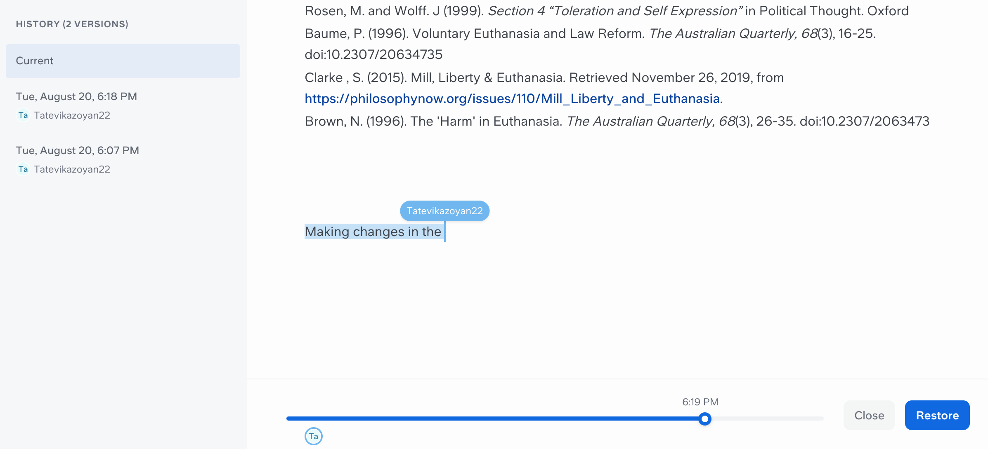  Slite – history (showing each change with time scroller + ability to restore)  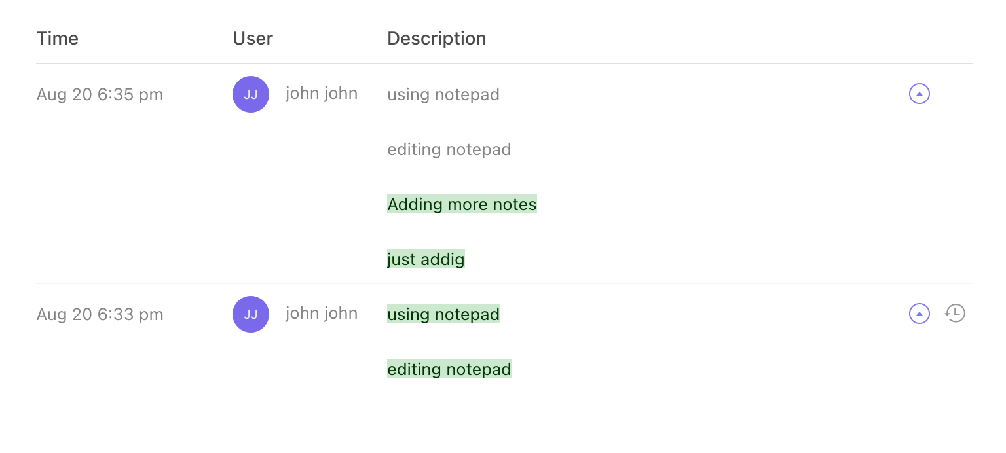  Click up – showing changes as a highlighted text in description  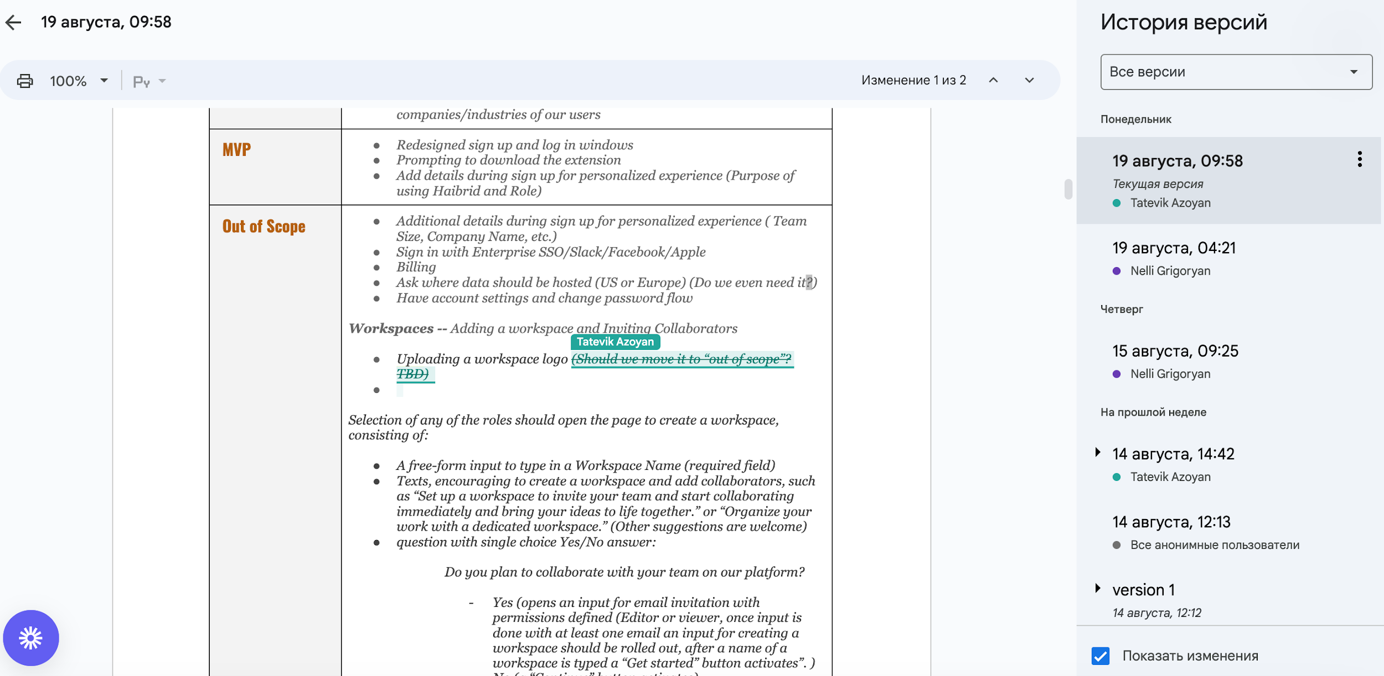  Google Doc  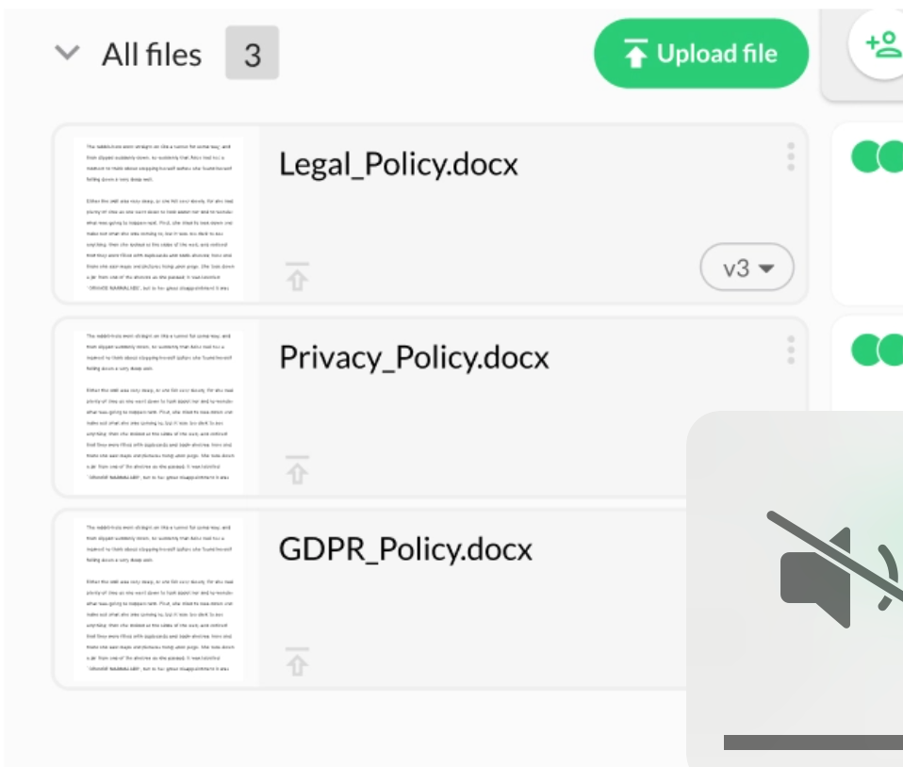  Keeping versions of files in a dropdown – v1, v2, v3
High-level Mock Ups

